
Policy Name | Attendance Policy
Policy Number | BWS 26 – Version 3
Date implemented | October 2019
Updated | Feb 2025
Implemented by | DC
Review date | Feb 2026 – WM

Attendance Policy
Contents
Statement and Vision 2
Aims 2
Objectives 3
Registration 3
Acknowledging good attendance 3
Punctuality 4
Roles and Responsibilities 4
Reviewing history 4

‘Inspiring a better future’
This policy is in line with the Independent School Standards (2015).

Statement and Vision
Birchwood School recognise that regular attendance and punctuality is essential if students are to make good progress at school and gain the appropriate skills, which will equip them for life. It is important to ensure that our most vulnerable students are given the appropriate support. The aim of this policy is therefore to encourage the highest possible levels of attendance for all students.
In order to achieve this, all members of the school community have an important contribution to make.
Birchwood School will:
- Promote a culture across the school which identifies the importance of regular and punctual attendance.
- Make attendance and punctuality a priority for all those associated with the school
- Further develop positive and consistent communication between school and home.
- Set targets to improve individual pupil and whole school attendance.
Birchwood School also recognises that many pupils come to us with a history of poor school attendance, or may have had a lengthy period out of school. The school therefore works with the pupils to encourage good attendance but does accept that for some pupils this may be a long proves of persuasion and perseverance.
The school accepts also the need to constantly review the curriculum at all Key Stages. The school aims to motivate pupils so much that they wish to attend and benefit from a curriculum which is enriched, diverse and relevant to their own individual needs.
Students are encouraged to develop the habit of regular and punctual attendance and learn to be responsible and reliable. Staff encourage good attendance and punctuality and liaise with parents/carers and other agencies where appropriate. In addition good attendance and punctuality are seen as achievements in their own right and are recognised as such by all.

Aims
- To create a culture where good attendance is ‘normality’
- To demonstrate to students, parents/carers and staff that the school values good attendance and to recognise that good, regular attendance is an achievement in itself.
- To be consistent in both rewards and sanctions.

Objectives
- To involve students in their school attendance
- All school staff to continue to take reasonability for pupils attendance

Registration
There are four broad classifications in the attendance register.
Present: Pupil on the school premises at the time of registration.
Approved Educational Activity: Pupil is engaged in approved supervised activity off site.
Authorised Absence: Pupil has the authority of the school to be absent, either given in advance or afterwards.
Unauthorised absence: No explanation received or unacceptable reason given.
Symbols used
/ Present
V Educational Visit/activity
M Medical
G Unauthorised absence.
L Late
W Work experience
B Education off site
The register is completed at the beginning of the morning and afternoon sessions. Parents/carers are encouraged to contact school if a student is absent. In the event that no contact is made the school will endeavour to make contact. If no contact is made then the SLT will be informed.

Acknowledging good attendance
Staff constantly praise and offer positive encouragement to pupils who are regularly punctual and have good attendance. Certificates for attendance will be awarded termly.

Punctuality
Members of staff are on duty each morning to greet pupils on arrival. Lateness is noted and is discussed with individual pupils. The school understands the need for on-going communication with parents/carers and pupils regarding this policy, particularly those new to the school.

Roles and Responsibilities
• It is the role of Birchwood School staff to work closely with our pupils and their parents/carers to improve or maintain good attendance and punctuality.
• The schools will always aim to meet the government expectations of 95% but due to the nature and needs of our pupils’ achievable targets and interventions are introduced once a pupil’s attendance drops below 90%.
• We will regularly monitor attendance and punctuality.
• We will always request medical evidence to support any absence due to illness. It is the parent/carers responsibility to request this and send it in with your child on their first day back to school following any absence
• The Pastoral lead will attend meetings regarding attendance concerns.

Appendix 1

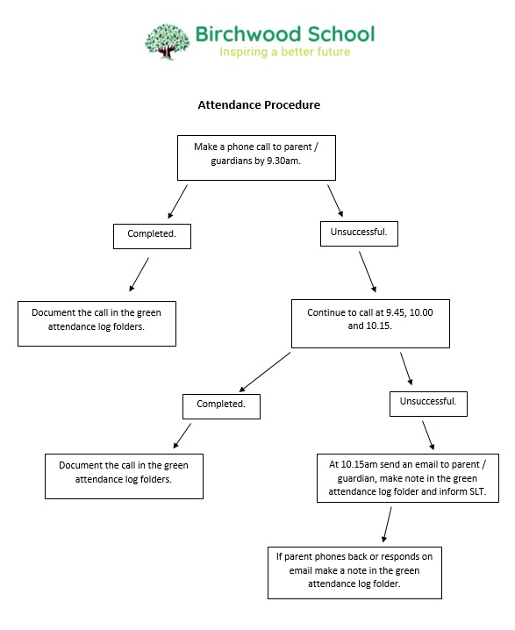

Reviewing history
Date | Changes made | Signature
Feb 2025 | Reviewed – small changes made | WM/SP

 | Name | Signature | Date | Department
1
2
3
4
5
6
7
8
9
10
11
12
13
14
15
16
17
18
19
20
21
22
23
24
25
26
27
28

